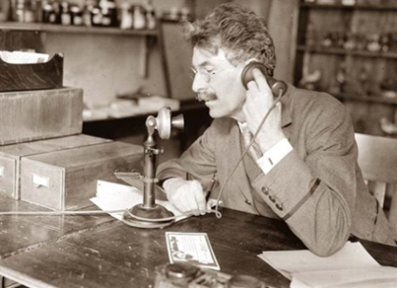 |  | 
Verleden tijd | Tegenwoordige tijd | Toekomst
Past | Present | FUTURE
Past Simple | Present Simple | Will/ Shall
Present Perfect | Present Continuous | Going to

 |  | Am / Are / Is going to |  | Will / Shall
When |  | Staat vast. Gaat zeker weten gebeuren in de toekomst. |  | Will: Een plan. Niet zeker of het zal gebeuren in de toekomst.  Shall: Ook een plan. Niet zeker of het zal gebeuren in de toekomst.  - Maar alléén bij vragende zinnen  - En alleen als ‘Ik’ of ‘Wij’ het onderwerp is.
Rule |  | Am/ Are/ Is going to + werkwoord |  | Will / Shall + werkwoord
 |  |  |  | Gewone zinnen | Vragende zinnen
How | I | am going to work |  | will work | Shall I work?
 | You | are going to work |  | will work | Will you work?
 | She/ He/ It | is going to work |  | will work | Will she/ he/ it/ work?
 | We | are going to work |  | will work | Shall we work?
 | They | are going to work |  | will work | Will they work?
Indicator |  | Certainly | Zeker | I think… | Ik denk…
 |  | No doubt | Zonder twijfel | Probably | Waarschijnlijk
 |  | Sure to happen | Zal zeker gebeuren | Sometime | Ooit
 |  | Definitely | Zeker weten | Once | Ooit eens
 |  | Absolutely | Absoluut | Maybe | Misschien

- Talk about the topic below with your neighbour.
- Your arrangements for this evening.
- Your intentions for the rest of the year.
- Your predictions for the planet for the year 2020.
B. Read these situations and circle whether to use Going to (GT) or Will/ Shall (WS).
- Predictions (when you can see the evidence) GT / WS
- Predictions (based on no evidence) GT / WS
- General future intentions GT / WS
- Decisions made at time of speaking (can be changed) GT / WS
- Promises GT / WS
- Decisions already made GT / WS
- Offers or refusals GT / WS

C. Circle the correct form of the Future tense.
- Peter knows that he (will / is going to) fly to Chicago next week.
- Oh no! I've broken the vase. What ( is my mum going to say / will my mum say)?
- Look at those clouds! It (is going to rain / will rain)!
- (Shall/Will) we feed the horses now or later?
- (Shall/Will) you help me carry the bags?
- Some day I (will be / am going to be) a millionaire.
- We (are going to / will go to) the cinema tonight.
- My stomach hurts. I (am going to / will) have some tea.

D. Fill in the gaps. You can choose from am going to / are going to / is going to / will / shall
or won’t.
- This weekend I ____________________ eat all the chips I can because I made a bet.
- You ____________________ do exactly as I say mister!
- Wessel ____________________ pick up his parents from the airport tomorrow.
- ____________________ I close the window now?
- My sister ____________________ the dentist next week.
- ____________________ you go to PSV’s next home game with me?
- Do you know if they ____________________ go to the school dance next month?
- Max Verstappen ____________________ ever win a grand prix if his car keeps breaking down.
- We ____________________be the best gardeners after we leave this school.
- Luca and Job ____________________ ace this assignment because they get it!

